**Link for Successful Story/Product:** [**https://demo.mapstory.org/story/1775**](https://demo.mapstory.org/story/1775)

***The following notes were compiled in the process of building this as well as in relation to the final/finished product:***

* Password Reset link did NOT work, landed instead on this page:

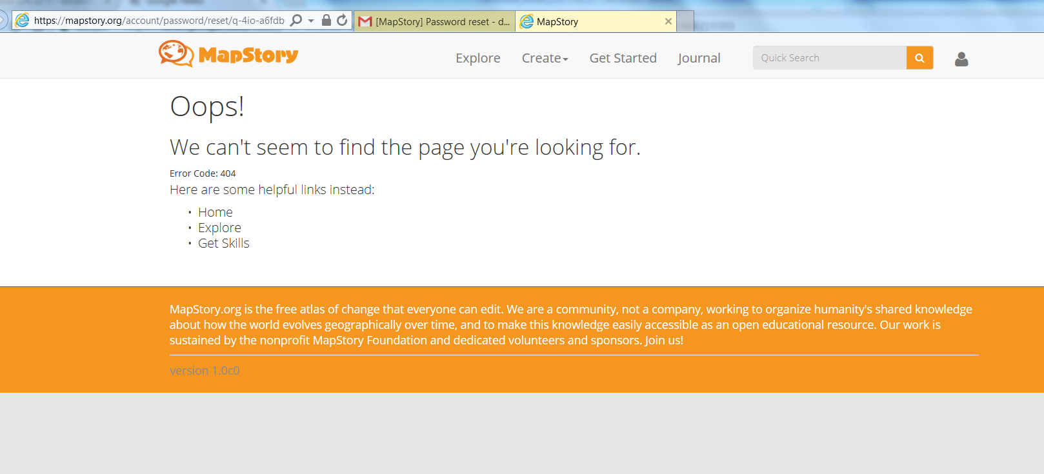

* Successfully created new account, and although the activation link did not work (same error page as above) I was able to use this new account to build the above link (to which the below feedback applies for process/output).
* Successfully imported data, pulled into composer, able to conduct limited modify on Layer Style, Publish MapStory, and share via both links (“Share”, as above, as well as “Embed”)
* Issues Encountered:
  + Map Viewing extent remains a problem. I can zoom in/out and pan around but it always snaps back to the extent of the layer; this is problematic for many reasons, but primarily because 1) in the story view mode, part of the viewer is by default blocked/impeded by the story/chapters outline on the left, 2) I cannot pan/adjust my view to account for additional impediments that may be otherwise useful to add (i.e. “Toggle Timeline” and “Playback Settings”), and 3) from the perspective of an end-user I would generally like to zoom in/out and pan around to explore data (in both a spatial and temporal capacity) however this is impossible as anytime the timeline continues to progress or is altered, the view snaps back to the entire layer extent.
  + Still cannot make sense or get functionality from Style options other than the most basic “Simple” setting – in this, I can successfully adjust SYMBOL size, shape, and color, as well as STROKE settings; however, attempts to add a LABEL result in the entire layer becoming invisible
  + Likewise, difficult to adjust the Legend display (it appears that a user needs to anticipate how they want the legend to display during the original import of the dataset, which is unwieldy especially if a dataset may be intended for use in more than one Story)
  + I can click on data points and see attributes in the Story Composer, but not when viewing as a final/published product. This is problematic because we would like an end user to be able to fully explore the data content in the finished presentation format.
  + Multiple error messages pop up during the basic story creation, metadata process, and while navigating the lefthand menu; these do not appear to affect the actual progress of Composer, however do impede and frustrate the user’s experience while building (in our case, fully inputting metadata was not possible due to continual error popup)
  + No apparent way to return “Home” from the Story Composer (Home button in upper left does not work)